**Applications of BFS:**

1. **Social Networking**: BFS can be used to find the shortest path between users in a social network, like finding mutual friends or recommending connections.



Bluetooth can be considered an example of a breadth-first search (BFS) algorithm in certain contexts, particularly in its discovery and pairing processes.

When a Bluetooth device wants to discover other devices, it typically sends out inquiry packets to find nearby devices. This process can resemble BFS in that it explores all nearby devices at one level (first, it looks for devices within range) before moving on to the next level (like discovering services or pairing with each device).

In a broader sense, BFS is used in networking and protocols to explore connections or routes systematically, which is applicable to how Bluetooth manages connections among multiple devices.

1. **GPS Navigation**: BFS can be applied to find the shortest path in navigation systems by exploring all possible routes from the start point.
2. **Broadcasting**: In networking, BFS is used for broadcasting messages to all nodes in a network.

**Customer service**:

In customer service systems, queries are often handled in a First-In-First-Out (FIFO) manner, which resembles BFS. Customers who enter the queue first are served first, rather than going deep into a complex query before handling simpler, newer ones.

• This ensures that everyone is served in a fair, layer-by-layer manner.

Finding nearby public facilities:

When searching for nearby public services (such as hospitals or ATMs) through a mobile app, the app often displays the closest facilities first and then gradually expands outward.

• This is a BFS-like search, as it finds the closest options before showing further options, ensuring the user has convenient access to nearby services first.

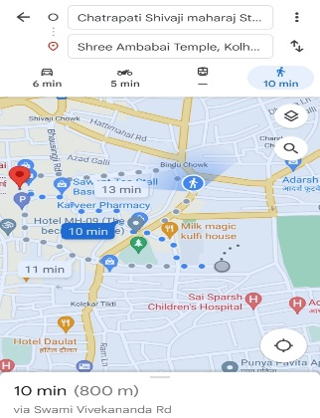

**Application of DFS:**

• **Backtracking Problems**: DFS is a common approach in problems like the N-Queens problem or Sudoku solving, where all possible configurations need to be explored.

Solving a Sudoku puzzle can be visualized as a DFS problem. You choose a cell and try different numbers, going deeper with each cell choice.

• If you reach a cell where no valid numbers fit, you backtrack and try a different number in the previous cell. This process continues until the entire puzzle is solved.

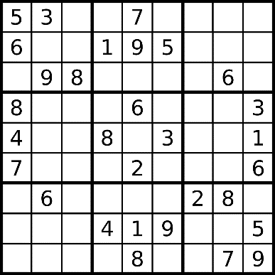

**File System Navigation**: When you explore directories in a computer's file system, DFS is often used. It dives deep into subdirectories before returning to explore other branches, much like how you might open a folder, then open a subfolder, and continue until you reach the deepest level before going back up.

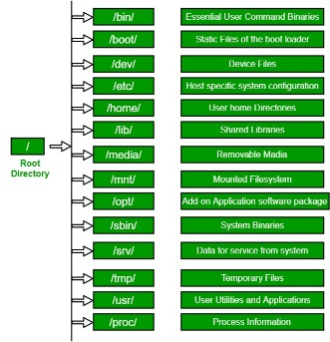

It also uses the stack techniques which is used by DFS to keep the track of visited nodes.

Family tree:

When tracing a family tree, if you want to follow a lineage as far back as possible (e.g., all ancestors along one branch), DFS is a natural fit. You explore one branch deeply until there are no further ancestors, then backtrack to explore the next branch.

• This allows you to trace the family tree deeply through generations along each branch before moving to the next.

